Chapter 19, Solution 18.

Calculate the y parameters for the two-port in Fig.19.79.
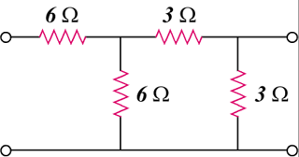

6 Ω

6 Ω

3 Ω

3 Ω

Figure 19.79
For Probs. 19.18 and 19.37.

Solution

To get and , consider the circuit in Fig.(a).

6

3

3

6

(a)

+

V₂ = 0

V₁
+

I₁

I₂

To get and , consider the circuit in Fig.(b).

6

3

3

6

(b)

+

V₁ = 0

+

I₁

I₂

V₂

I_{o}

,

Thus,

